

SUPERMARKET INCOME REIT PLC

(the “Company”)

(incorporated in England & Wales registered number 10799126)
LSE Share Code: SUPR
JSE Share Code: SRI

ISIN Code: GB00BF345X11
LEI: 2138007FOINJKAM7L537

Computershare Investor Services (Pty) Limited
Reg No 2004/003647/07

PROXY FORM
ANNUAL GENERAL MEETING OF SHAREHOLDERS TO BE HELD ON 25 NOVEMBER 2026 AT 11.00 AM (UK TIME)
/ 13.00 PM (SA TIME)

Only for use by certificated shareholders or dematerialised shareholders of Supermarket Income REIT plc (the “Company’’) who have selected “own-name” registration.

For use by Supermarket Income REIT plc shareholders on the South African register at the Annual General Meeting (the “AGM”) of the Company to be held on Wednesday, 25 November 2026 at the offices of Macfarlanes LLP, 20 Cursitor Street, London EC4A 1LT at 11.00 am (UK time) / 13.00 pm (SA time) and at any adjournment or postponement thereof. If you have dematerialised your shares with a Central Securities Depository Participant (“CSD Participant”) or broker and have not selected “own-name” registration, you must arrange with your CSD Participant or broker to instruct them as to how you wish to vote at the AGM. This must be done in terms of the agreement entered between you and the CSD Participant or broker.

I/We (Names in full – please print)

of (address – please print):

being the holder of shares in Supermarket Income REIT plc hereby appoint:

1. of or failing him/her,

2. of or failing him/her,

the Chair of the meeting as my/our proxy to attend and vote for me/us at the AGM and at any adjournment thereof, and, if deemed fit, passing, with or without modification, the resolutions to be proposed thereat in accordance with the following instructions (see notes):

Signed at on 2026
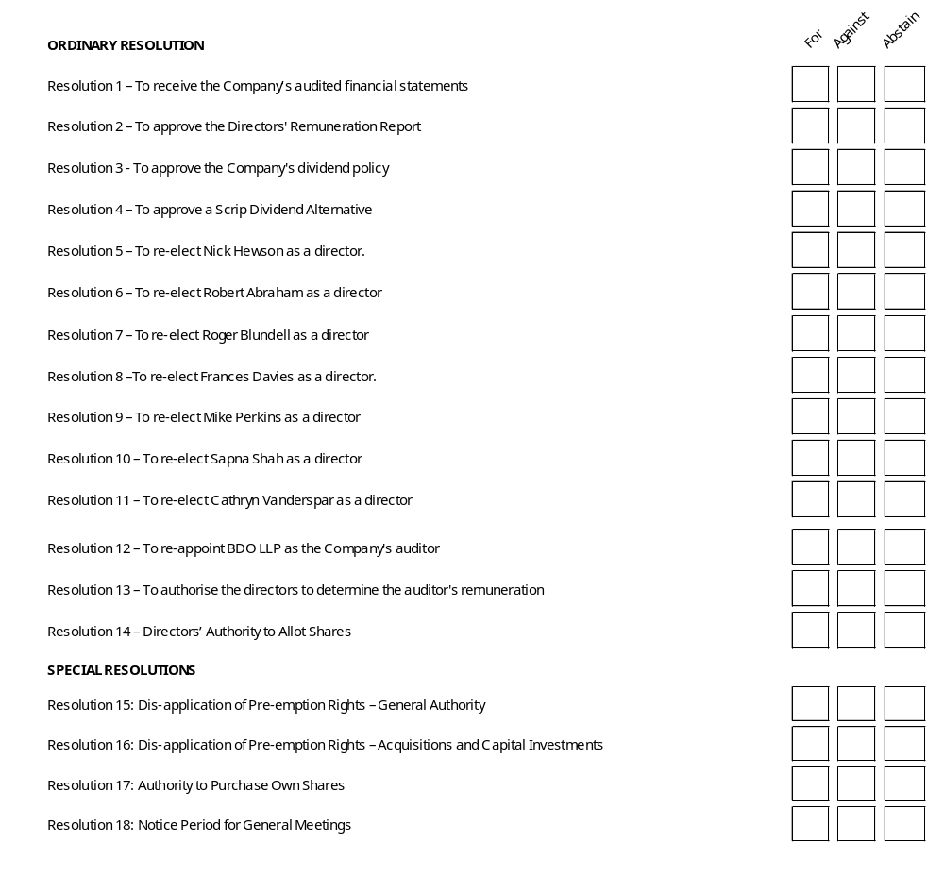
Name
(In block letters)
Signature/s
Assisted by me
(If applicable)
Full name/s of signatory/ies if signing in a representative capacity
(In block letters, and authority to be attached – see note 9)

Please read the notes below:

NOTES
- Each shareholder is entitled to appoint one or more proxies (none of whom need be a shareholder of Supermarket Income REIT plc) to attend, speak, vote or abstain from voting in place of that shareholder at the AGM.

- Forms of proxy must be lodged with or posted to the South African Transfer Secretaries, Computershare Investor Services (Pty) Limited, Rosebank Towers, 15 Biermann Avenue, Rosebank, 2196 (Private Bag X9000, Saxonwold, 2132; or email to proxy@computershare.co.za, to be received by no later than 11.00 am (UK
time) / 13.00 pm (SA time) on Monday 23 November 2026.

- If the signatory does not indicate in the appropriate place on the face hereof how he/she wishes to vote in respect of any resolutions, the Chair of the meeting as the proxy shareholder will vote in favour of the resolution.

- The Chair of the meeting shall be entitled to decline to accept the authority of a person signing this form of proxy:
  - under a power of attorney; or
  - on behalf of a company.

Unless the power of attorney or authority is deposited at the office of Supermarket Income REIT plc’s Transfer Secretaries, not less than 48 hours before the time appointed for the holding of the AGM.

- The Chair of the meeting may reject or accept any form of proxy, which is completed and/or received other than in accordance with these notes, provided that the Chair of the meeting is satisfied as to the manner in which the shareholder concerned wishes to vote.

- A deletion of any printed matter and the completion of any blank spaces need not be signed or initialled. Any alterations must be signed, not initialled.

- If the holding is not indicated on the form of proxy, the proxy will be deemed to be authorised to vote the total holding registered in the shareholder’s name.

- A vote given in terms of an instrument of proxy shall be valid in relation to the AGM, notwithstanding the death of the person granting it, or the revocation of the proxy, or the transfer of the shares in Supermarket Income REIT plc in respect of which the vote is given, unless an intimation in writing of such death, revocation or transfer is received by the Transfer Secretaries no less than 48 hours before the commencement of the AGM.

- Documentary evidence establishing the authority of a person signing this form of proxy in a representative capacity (e.g. for a company, close corporation, trust, pension fund, deceased estate, etc.) must be attached to this form of proxy unless previously recorded by Supermarket Income REIT plc or its Transfer Secretaries or waived by the Chair of the meeting.

- Where this form of proxy is signed under power of attorney, such power of attorney must accompany this form of proxy, unless it has previously been registered with Supermarket Income REIT plc or its Transfer Secretaries.

- Where there are joint shareholders of shares and if more than one such joint shareholder is represented, then the person whose name appears first in the register of such shares or his/her proxy, as the case may be, shall alone be entitled to vote in respect thereof.

- Where shares are held jointly, all joint shareholders are required to sign.

- A minor must be assisted by his/her parent or guardian, unless the relevant documents establishing his/her legal capacity have been registered by the Transfer Secretaries of Supermarket Income REIT plc.

- Dematerialised shareholders who have not selected “own-name” registration and who wish to vote by way of proxy must advise their CSD Participant or broker who will issue the necessary letter of representation in writing for a dematerialised shareholder or proxy to do so.

- If this proxy is not dated, it will be deemed to bear the date on which it is mailed by Management to the shareholder.

- This proxy confers discretionary authority in respect of amendments to matters identified in the Notice of the AGM or other matters that may properly come before the meeting.
Transfer Secretaries
Computershare Investor Services (Pty) Ltd.
Reg. No. 2004/003647/07
Proxy Dept. Private Bag X9000, Saxonwold, 2132, South Africa
Fax: +27 11 688-5238
Email: proxy@computershare.co.za

